Actividades de Inglés
Curso: 2º (TODOS)
Profesora: Somaruga, Gioia

Email para consultas y entregas: gsomarug@hotmail.com

Fecha de Entrega: 15 de abril.

Chicos y chicas: Por favor, no dejen de escribirme, escriban sus dudas a mi mail, y hagan lo que puedan. Yo sé que el año pasado y este han sido años muy particulares. No dejen de escribirme que yo los ayudo. Cuídense mucho.

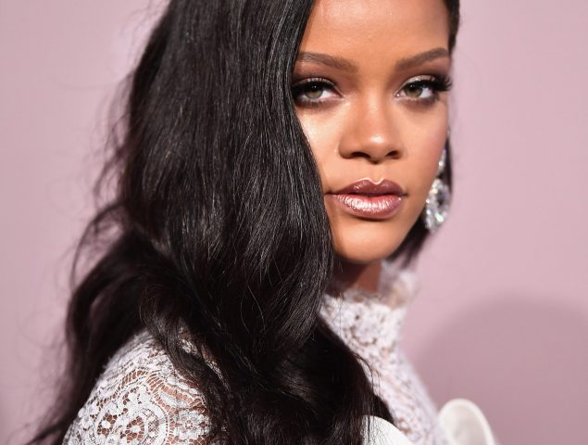

Read the text carefully
Rihanna is a singer. She is from Barbados but now she works all over the world. She is twenty-four years old and she´s very famous. She has got big brown eyes and she is tall.
She has got a lot of hit songs: Umbrella, Please don´t stop the music, Disturbia, etc. The songs are so good that she has a lot of fans of all over the world, they love her music.
Rihanna´s mother is called Monica and her father´s name is Ronald.

Grammar:
- Underline the Verb to be. (are, is or am)
- Underline two adjectives.
- Underline the two forms of the verb “Have got”.

- Decide if the sentences are True or False:

- Rihanna isn´t a teacher. …………….
- Rihanna is Barbadian. …………….
- She isn´t very famous. ………………..
- Rihanna is very short. ……………………..
- She hasn´t got many fans. ………………….
- Monica and Ronald are her grandparents. ………………

- Answer the following questions:
a.What is Rihanna´s job?
…………………………………………………………..
b. Where is she from?
…………………………………………………………..
c.How old is she?
…………………………………………………………..
d.Is she famous?
…………………………………………………………..
e.What does she look like?
………………………………………………………….
f.What is her mother´s name?
…………………………………………………………..
2. Make your own sentences with There is/There are. (Describe your bedroom)
e.g: there is a big teddy bear in my bedroom.
1 …………………………………………………
2. …………………………………………………
3. ………………………………………….........
4. ………………………………………………..
5. ………………………………………………….

