COLEGIO: CPEM 46
ASIGNATURA: INGLÉS
CURSO: 2DO A
PROFESORA: ALICIA POCHETTINO
EMAIL: aliv882@hotmail.com
FECHA: 14/09/2020
FECHA APROXIMADA DE ENTREGA: 28/09/2020

¡Hola segundo año A! ¿Cómo están? Espero que muy bien. Aquí les dejo un nuevo trabajito, en el que seguiremos aprendiendo más sobre el Presente Simple. Good luck!

TRABAJO PRÁCTICO N° 10
Repasemos cómo se forman las oraciones afirmativas, negativas y también las preguntas (oraciones interrogativas) en Present Simple….
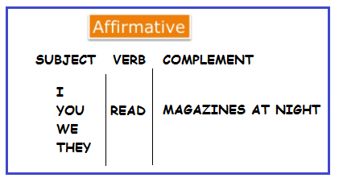
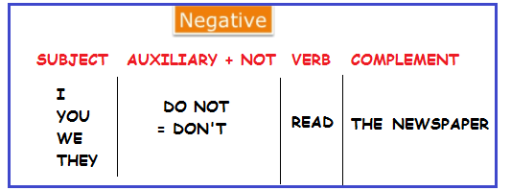
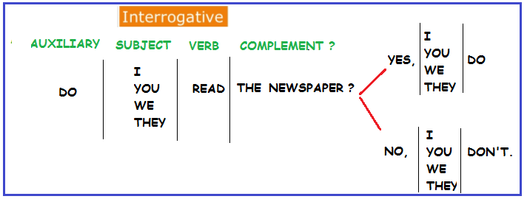
Ahora a practicar mucho!!!!
1) Vocabulary:
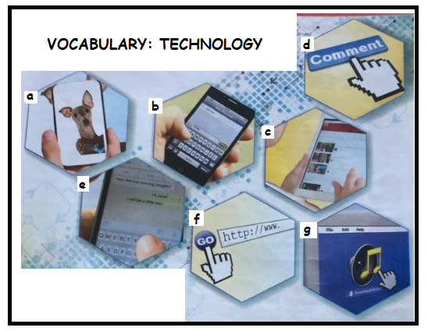
2) Look at the images and complete with the correct letter.
- Take and send photos: …………
- Send messages: ………….
- Watch videos on YouTube ………..
- Chat online: ……………
- Do research: ……………
- Download music: ……………
- Post comments/photos: ……………..
3) Now complete the sentences with the verbs from the box:
- I love my mobile phone. I ………………….messages to my friends.
- I’ve got a computer. I ………………………music and then listen to the songs.
- I use my laptop every day. I………………..online, I look at photos and …………………comments.
- We’ve got a computer at home. I ……………………research or ………………………..videos. My little brother plays online games.
4) Turn these sentences into the negative form. There is an example.
a- I do my homework at night
Negative: I don’t do my homework at night.
b- We live in Brazil.
Negative: ……………………………………………………………….
c- They chat with friends at weekends.
Negative: ……………………………………………………………….
d- You walk to school.
Negative: …………………………………………………………………
e- I study English every day.
Negative: ……………………………………………………………………
5) Read the following text:
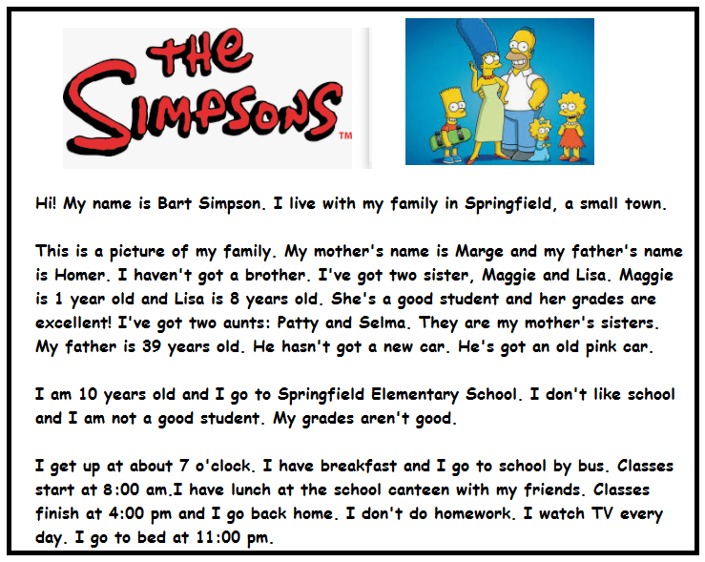
A- Answer the following questions:
- Do the Simpsons live in Springfield? Yes, they do.
- Have they got a new car?
- Do classes start at 8:00?
- Do classes finish at 5 pm?
B- Now answer as if you were Bart (Responde como si tú fueras Bart Simpson)
- What is your mother’s name?
- Is your sister a good student?
- Are you a good student?
- What time do you get up?
- Do you go to school by bus?
- Do you have lunch at home?
- Do you watch TV every day?
- What time do you go to bed?

6) READ AND WRITE
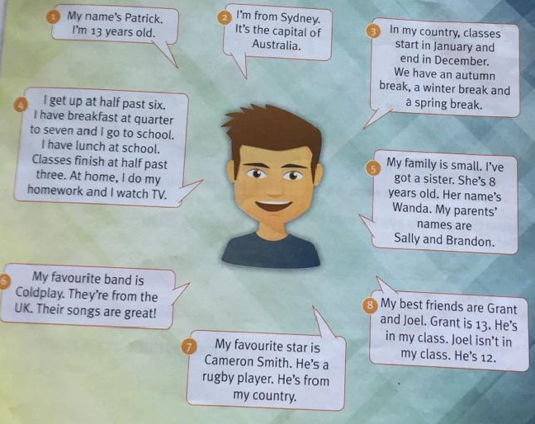
Lee bien la información sobre Patrick y luego, siguiendo los números y el mismo modelo, escribe sobre tu vida.
1) (Name and age): My name ……
2) (City and country): I’m from … or: I live…
3) (School calendar): In my country clases start….
4) (Routine): I get up…
5) (Family): My family….
6) (Favourite band): My favourite band…
7) (Favourite star): My favourite star…
8) (Friends): My best friend…

