**COLEGIO:** CPEM 46

**ASIGNATURA:** LENGUA EXTRANJERA INGLÉS

**CURSO:** 5° D

**FECHA:** 12/11/2020

**PROFESORA:** Cecilia Calantoni

**CORREO ELECTRÓNICO PARA ENVÍO DE TRABAJOS Y CONSULTAS:** ceciliacalantoni@gmail.com

**INSTANCIAS DE PROMOCIÓN 2020/2021**

1) Los estudiantes que reciban en sus informes la palabra APROBADO, ya finalizaron con la materia.

2) Los estudiantes que reciban en sus informes EN PROCESO 2020:

· Continuarán trabajando desde el 9 hasta el 27 de noviembre de 2020.

· Podrán realizar consultas a la profesora mediante correo electrónico (ver arriba) todas las veces que lo necesiten para poder aclarar sus dudas.

· Durante este período, deberán entregar TODOS los trabajos prácticos que envió la profesora durante el año.

· Una vez finalizado este período recibirán un nuevo informe: APROBADO (si cumplieron con los requisitos mencionados) o EN PROCESO 2021 (si no cumplieron los requisitos).

3) Los estudiantes que reciban en sus informes EN PROCESO 2021:

· Trabajarán desde el 9 hasta el 27 de noviembre de 2020 y continuarán en febrero/marzo 2021.

· Durante el mes de noviembre podrán realizar las consultas a la profesora mediante correo electrónico (ver arriba) todas las veces que lo necesiten.

· Durante febrero/marzo 2021 deberán completar TODOS los trabajos prácticos realizados durante el 2020, y además parte de un cuadernillo de revisión y práctica: PÁGINAS 1, 2, 6, 7, 8, 11, 12, 15, 31, 32, 34, 40 y 41.

Nota: El cuadernillo de ejercitación estará disponible en Copy Express de calle Diagonal España 416, para que los alumnos puedan retirarlo impreso o solicitarlo mediante correo electrónico a: copyexpressdiagonal@hotmail.com, ya que esta empresa cuenta con envío a domicilio en caso de que alumnos no puedan acercarse

Prof. Cecilia Calantoni

**TRABAJOS PRACTICOS**

**Inglés 5° Año**

**Trabajo Práctico N° 1**

Please, do the activities on the following pages. You can use an English-Spanish dictionary. If you don’t have a dictionary at home, you can use these on line.

<https://www.collinsdictionary.com/es/traductor> This one is very similar to Google translator, so I guess you’ll like it. Please, don’t use Google translator. It has many mistakes.

<https://www.linguee.es/>

<https://dictionary.cambridge.org/es/diccionario/ingles-espanol/>

<https://www.wordreference.com/es/en/translation.as>



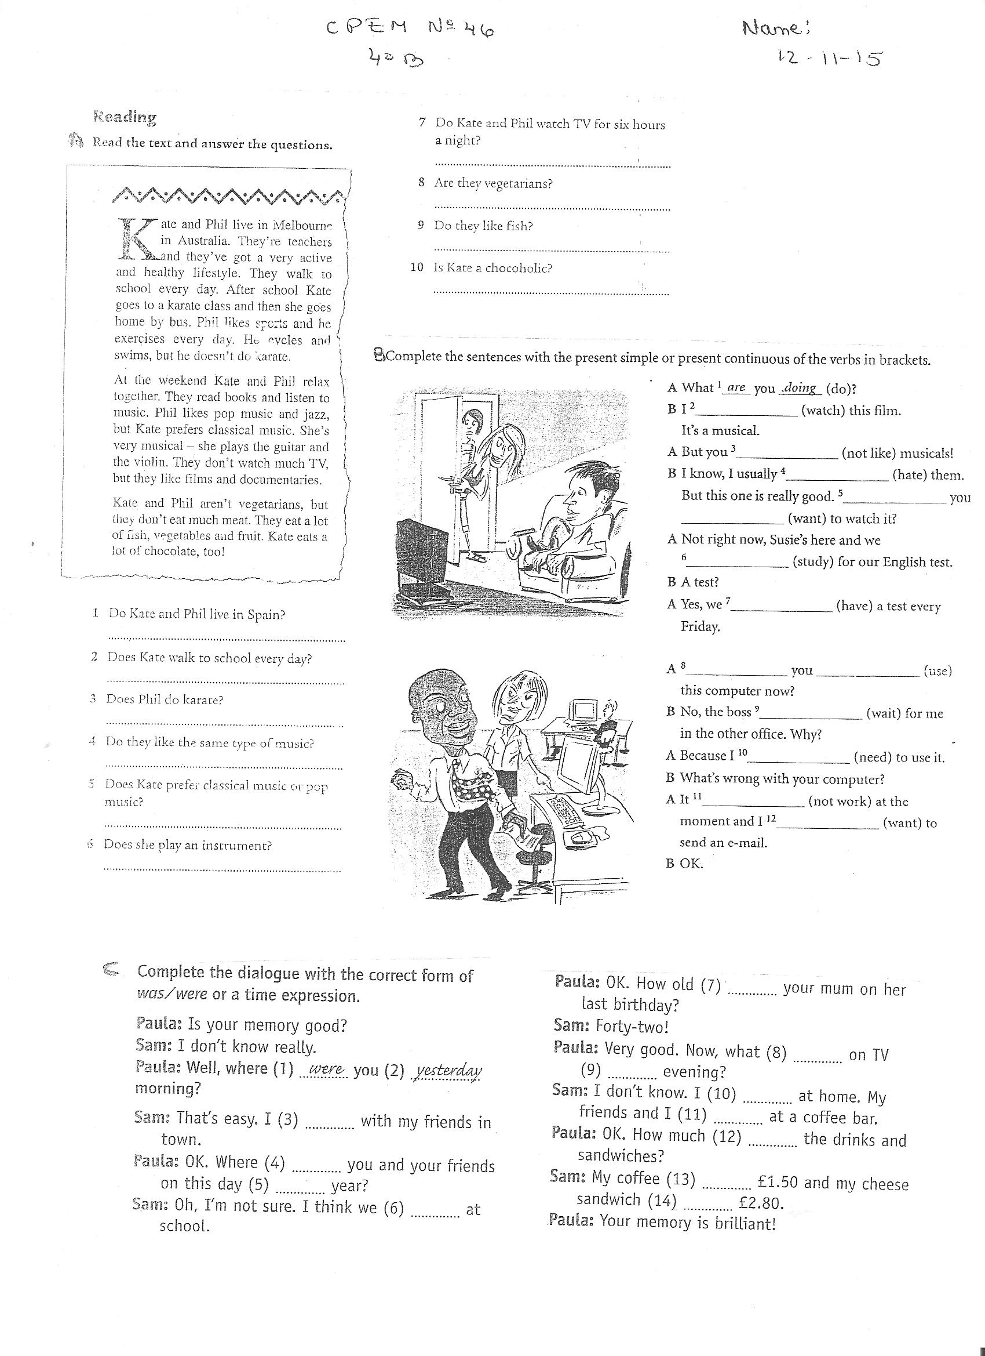

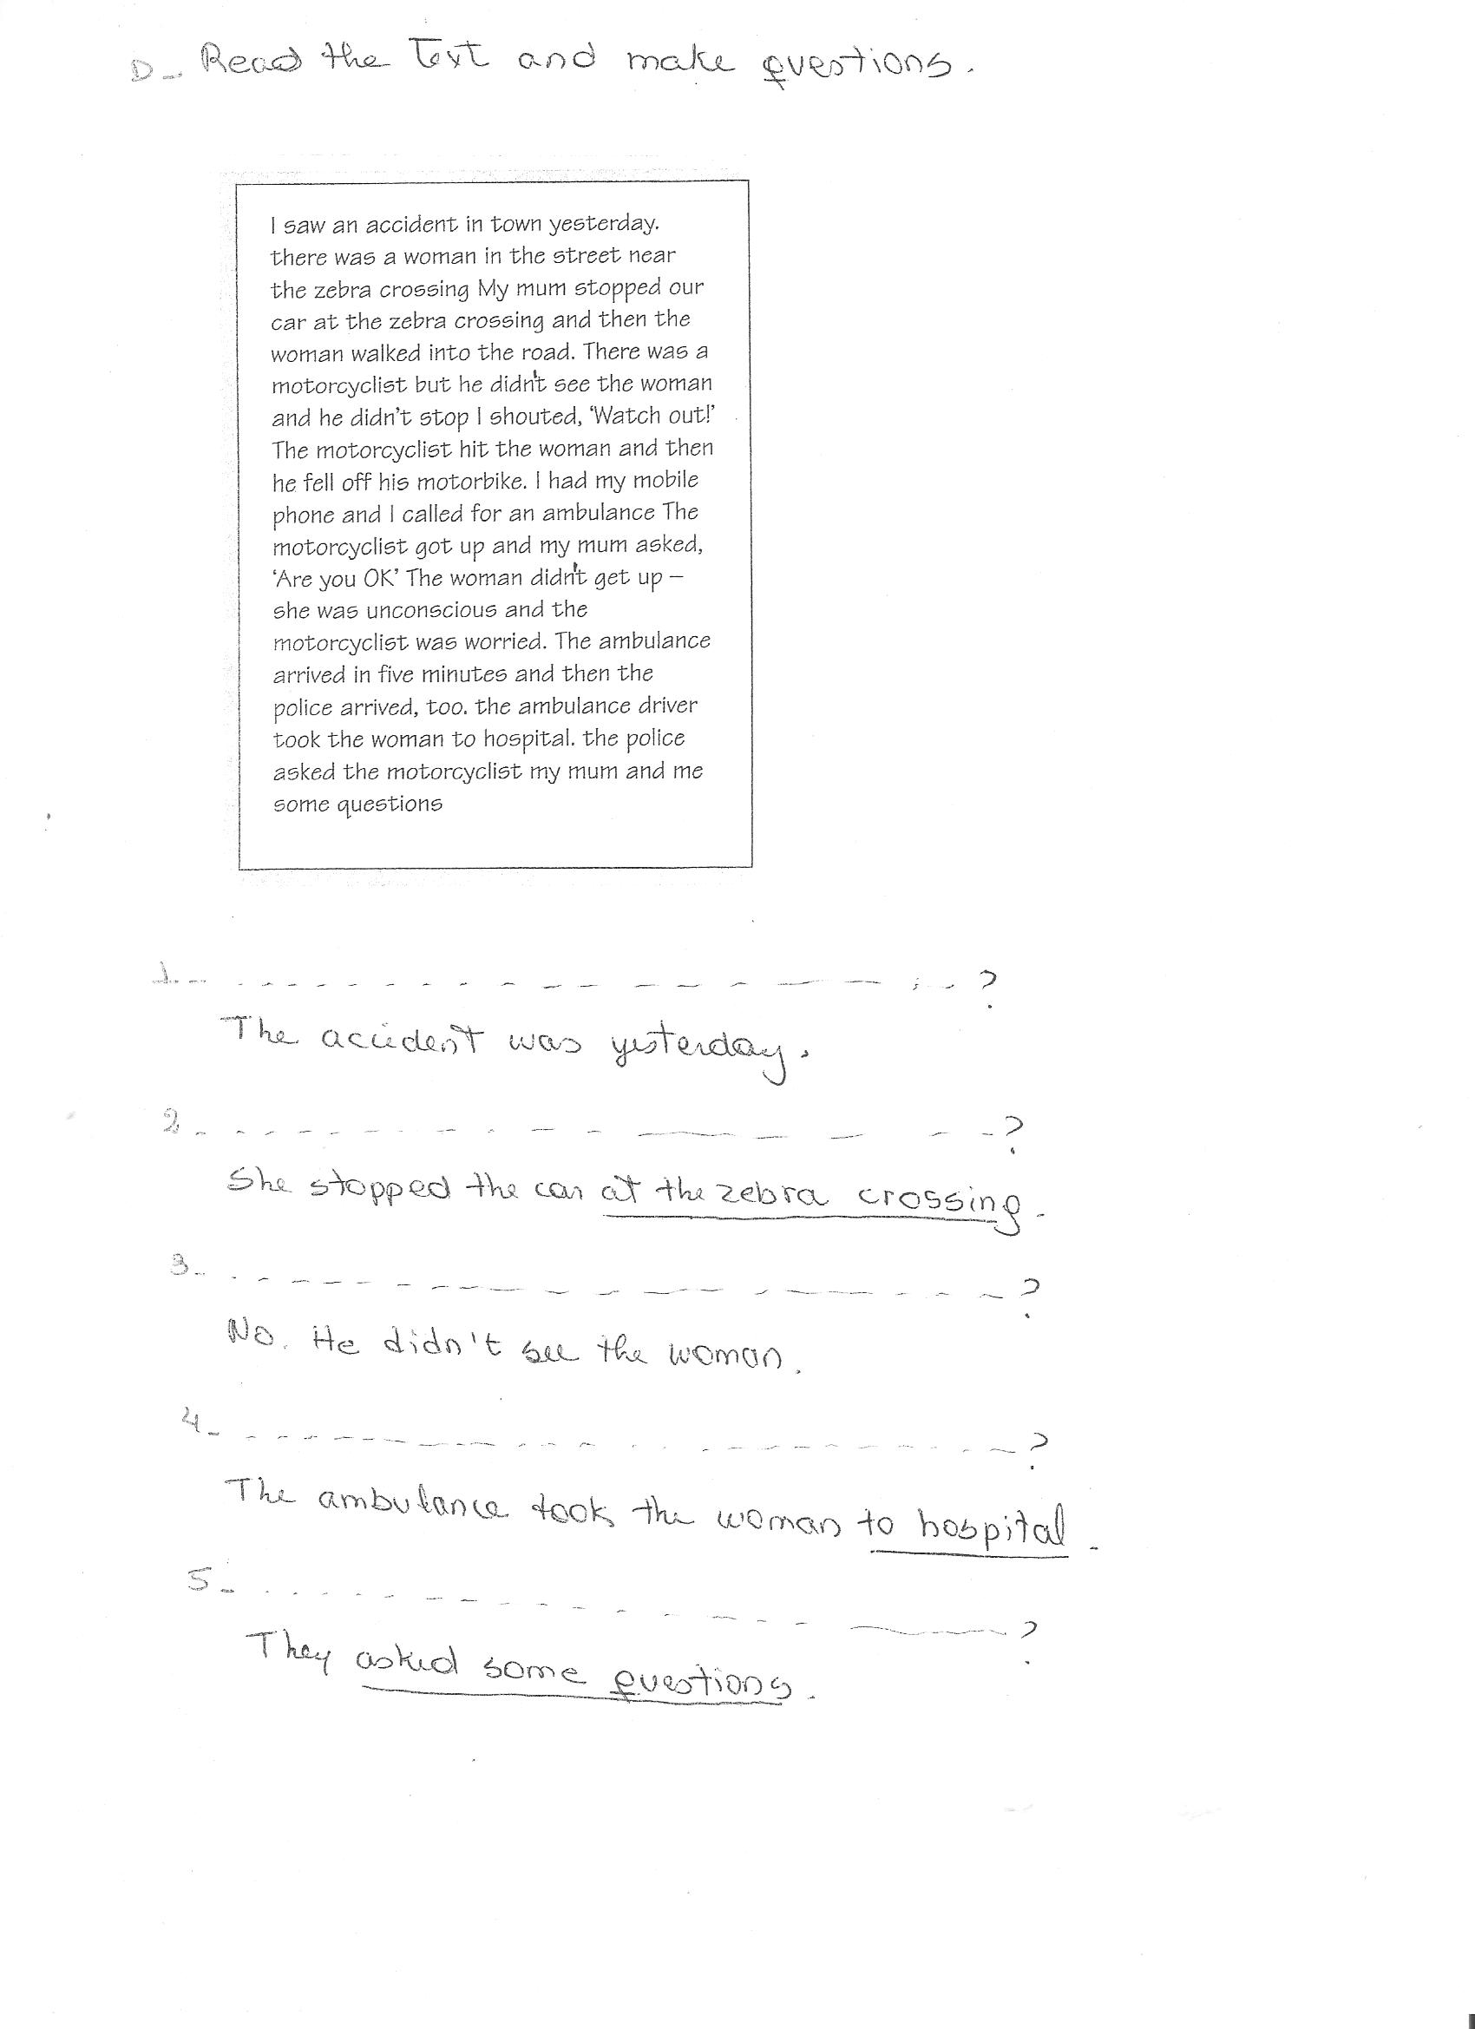

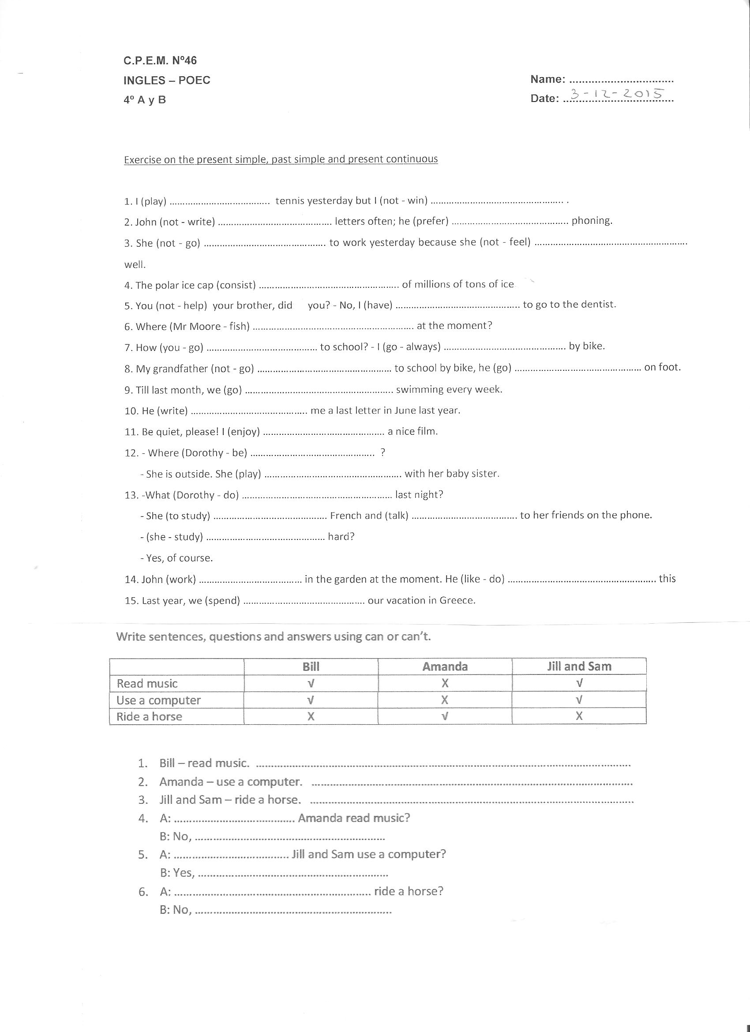





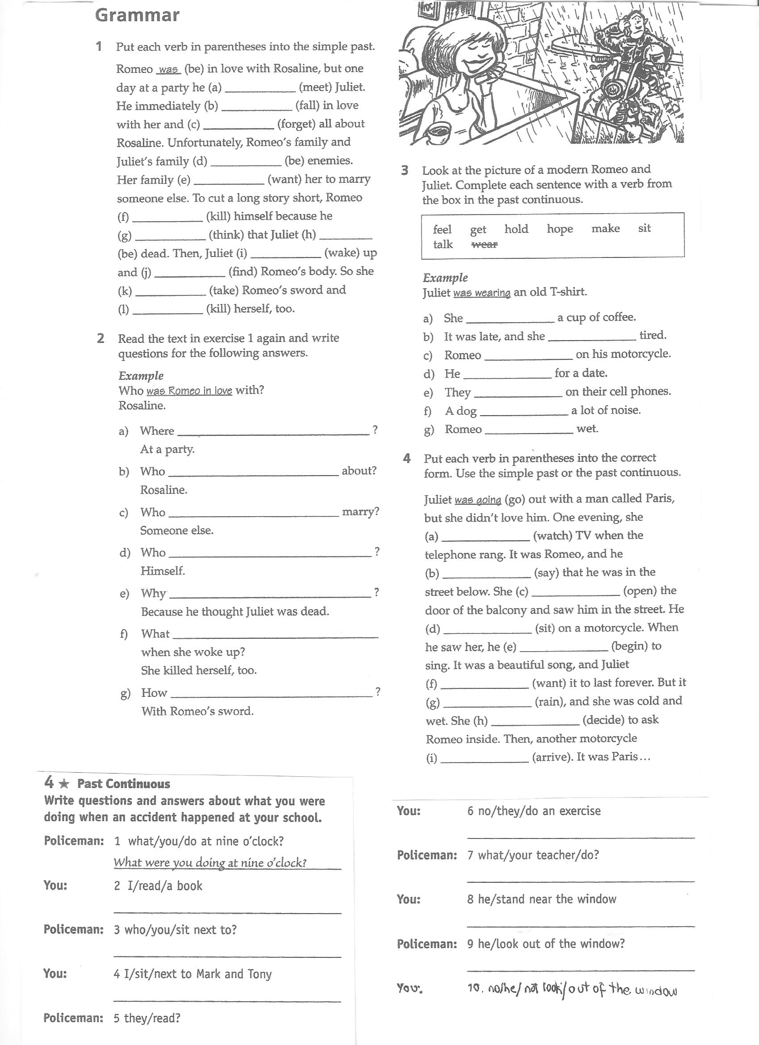



**Trabajo Práctico N° 2**

Reading comprehension

1. Read and answer

Today, millions of people want to learn or improve their English but it is difficult to find the best method. Is it better to study in Britain or America or to study in your own country?

The advantages of going to Britain seem obvious. Firstly, you will be able to listen to the language all the time you are in the country. You will be surrounded completely by the language wherever you go. Another advantage is that you have to speak the language if you are with other people. In Italy, it is always possible, in the class, to speak Italian if you want to and the learning is slower.

On the other hand, there are also advantages to staying at home to study. You don't have to make big changes to your life. As well as this, it is also a lot cheaper than going to Britain but it is never possible to achieve the results of living in the UK. If you have a good teacher in Italy, I think you can learn in a more concentrated way than being in Britain without going to a school.

So, in conclusion, I think that if you have enough time and enough money, the best choice is to spend some time in the UK. This is simply not possible for most people, so being here in Italy is the only viable option. The most important thing to do in this situation is to maximise your opportunities: to speak only English in class and to try to use English whenever possible outside the class.

1. What is the article about?
2. How many people learn English.
3. The best way to learn English.
4. English schools in England and America.
5. What is one of the advantages of going to the UK to learn English?
6. There are no Italians in Britain.
7. You will have to speak English and not your language.
8. The language schools are better.
9. What is one of the advantages of staying in your country to learn English?
10. The teachers aren't very good in Britain.
11. You have to work too hard in Britain.
12. Your life can continue more or less as it was before.
13. People who don't have a lot of time and money should...
14. Learn English in Britain.
15. Try and speak English in class more often.
16. Go to Italy to learn English.

B. Complete using Past Simple or Past Continuous

1. What ________________________ (you / do) when I ________________________ (call) you last night?

2. I ________________________ (sit) in a café when you ________________________ (call).

3. When you ________________________ (arrive) at the party, who ________________________ (be) there?

4. Susie ________________________ (watch) a film when she ________________________ (hear) the noise.

5. Yesterday I ________________________ (go) to the library, next I ________________________ (have) a swim, later I ________________________ (meet) Julie for a coffee.

6. We ________________________ (play) tennis when John ________________________ (hurt) his ankle.

7. What ________________________ (they / do) at 10pm last night? It ________________________ (be) really noisy.

8. He ________________________ (take) a shower when the telephone ________________________ (ring).

9. He ________________________ (be) in the shower when the telephone ________________________ (ring).

10. When I ________________________ (walk) into the room, everyone ________________________ (work).

11. It ________________________ (be) a day last September. The sun ________________________ (shine), the birds ________________________ (sing). I ________________________ (walk) along the street when I ________________________ (meet) an old friend.

12. He ________________________ (live) in Russia when the Revolution ________________________ (start).

13. When her train ________________________ (get) to the station, we ________________________ (wait) on the platform.

14. He ________________________ (be) so annoying! He ________________________ (always / leave) his things everywhere.

15. On holiday we ________________________ (visit) Rome, ________________________ (see) the Vatican, and ________________________ (spend) a few days at the beach.

16. Why ________________________ (you / stand) on a chair when I ________________________ (come) into the room?

17. They ________________________ (live) in Germany when they ________________________ (be) young.

18. At 7pm yesterday, we ________________________ (listen) to music.

19. When I ________________________ (leave) the house, it ________________________ (snow).

20. He ________________________ (work) in a bank when he ________________________ (meet) his wife.

C. Do this exercise.

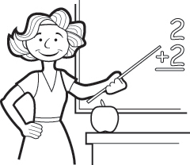

This is Mrs White. She …………… (be) a primary school teacher.

She …………………………… (teach) English, Maths and Geography.

At the moment, she …………………………… (teach) Maths.

She …………………………… (live) in London and ………………… (be)

married to Georges, who is French. They …………………………… (have) three children. They all …………………………… (love) animals, but they …………………………… (not have) any pets because they …………………………… (live) in an apartment. Mrs White ……………………… (speak) French as well as English, but she …………………………… (not teach) it.

=====

Mrs White’s niece Sophie …………………………… (stay) with the Whites for a few days. Sophie …………………………… (live) and …………………………… (study) in Liverpool, but she ……………………………… (enjoy) her mid-term break in London at the moment. She …………………………… (plan) to do some serious shopping and sightseeing.

=====

Mrs White’s son Arnold …………………………… (not like) shopping, but he …………………………… (love) hanging out with friends. They usually …………………… (go) to the local park where they ……………………… (play) football or basketball.

Today, however, Arnold ……………………………….…. (not play) football or basketball; he …………………………….. (skateboard).

=====

Mr White ………………… (work) for a multinational company. He ………………………… (not work)

today, however, because he ……………………………. (not feel) well. He phoned in sick.

**Trabajo Práctico N° 3**

Read an article about how people at different ages use computers and smartphones to practise and improve your reading skills.

Digital habits across generations

Before reading

Do the preparation task first. Then read the text and do the exercises.

Preparation task

1. *Match the definitions (1–8) with the vocabulary (a–h).*

**Vocabulary**

**1. …… to miss out on**

**2. …… addiction**

**3. …… constantly**

**4. …… to be cut off from**

**5. …… unlike**

**6. …… social media**

**7. …… ironically**

**8. …… early adopters**

*Definitions*

*a. websites and apps like Facebook, Twitter and Instagram*

*b. in a funny or strange way because it’s unexpected*

*c. different from*

*d. to not get the benefits of*

*e. needing something too much or in an unhealthy way*

*f. people who are the first to buy or use new technology*

*g. all the time without a break*

*h. to have no access to*

Reading text: Digital habits across generations

Today’s grandparents are joining their grandchildren on social media, but the different generations’ online habits couldn’t be more different. The over-55s are joining Facebook in increasing numbers, meaning that they will soon be the site’s second biggest user group, with 3.5 million users aged 55–64 and 2.9 million over-65s.

Sheila, aged 59, says, ‘I joined to see what my grandchildren are doing, as my daughter posts videos and photos of them. It’s a much better way to see what they’re doing than waiting for letters and photos in the post. That’s how we did it when I was a child, but I think I’m lucky I get to see so much more of their lives than my grandparents did.’

Ironically, Sheila’s grandchildren are less likely to use Facebook themselves. Children under 17 are leaving the site – only 2.2 million users are under 17 – but they’re not going far from their smartphones. Chloe, aged 15, even sleeps with her phone. ‘It’s my alarm clock so I have to,’ she says. ‘I look at it before I go to sleep and as soon as I wake up.’

Unlike her grandmother’s generation, Chloe’s age group is spending so much time on their phones at home that they are missing out on spending time with their friends in real life. Sheila, on the other hand, has made contact with old friends from school she hasn’t heard from in forty years. ‘We use Facebook to arrange to meet all over the country,’ she says. ‘It’s changed my social life completely.’

Teenagers might have their parents to thank for their smartphone and social media addiction as their parents were the early adopters of the smartphone. Peter, 38 and father of two teenagers, reports that he used to be on his phone or laptop constantly. ‘I was always connected and I felt like I was always working,’ he says. ‘How could I tell my kids to get off their phones if I was always in front of a screen myself?’ So, in the evenings and at weekends, he takes his SIM card out of his smartphone and puts it into an old-style mobile phone that can only make calls and send text messages. ‘I’m not completely cut off from the world in case of emergencies, but the important thing is I’m setting a better example to my kids and spending more quality time with them.’

Is it only a matter of time until the generation above and below Peter catches up with the new trend for a less digital life?

Tasks

**Task 1**

Are the sentences true or false? Answer

1. More people aged 55 or more use Facebook than people aged 65 or more.

2. Grandparents typically use Facebook less than their grandchildren.

3. Sheila feels grateful to social media.

4. Peter found his own smartphone use affected how he felt about how much his children used their phones.

5. Peter has changed how much he uses his phone during the working day.

6. Peter feels that the changes make him a better parent.

**Task 2**

Write the phrases in the correct group.

1. are returning to older technology
2. are less keen on Facebook
3. like to keep their phones near them
4. use social media to find old friends
5. were the first generation to get smartphones
6. feel lucky to have the internet in their lives

*Teens:*

*Grandparents:*

*Parents:*

1. **Present Simple or Present Continuous or Past Simple or Past Continuous**

1. Water ______________ (not/boil) at 0 degrees- it ____________ (boil) at 100.

2. When Chuck Norris _______________ (run) after a bad guy, he **always** ______________ (catch) him.

3. **While** Chuck ____________________ (eat) dinner, he ________________ (load) his gun.

4. **Every day** Chuck _______________ (get up) at 7 o’clock- he ____________ (not/get up) at noon. He has missions to accomplish.

5. Why _______ you __________ (call) me 20 times **yesterday**? _________ you ___________ (realize) that my phone __________________ (not/work)?

6. I can’t stand Justin. He _________**always** ________________ (throw) things in class.

7. **Right now** our English teacher _________________(talk) to us about the past continuous and the whole class ________________(sleep)- they _______________ (not/listen) to her.

8**. Look**! Chuck Norris is outside and he ____________ (walk) by our school!

9. **In 1850** nobody ______________ (play) Minecraft. There ____________ (not/be) any computer games then and worst of all- there ___________ (not/be) any TV!

10. After school I **usually** ____________ (watch) TV to relax and then I ___________ (do) my homework.

11. **This week** my handball team __________________ (practice) three times instead of two.

We _________________ (play) against the Halandri team **on Saturday**.

12. Chuck Norris ____________ (drive) his Lotus very fast **when** a giant monster ____________ (appear in front of him. He __________ (stop) in time.

13. Sorry, Mrs. Crabtree, I _____________ (not/find) my English homework. I think I ____________(leave) it at my friend’s house **last night**.

14. Chuck Norris ___________(not/believe) in ghosts. He ___________ (think) they _________ (not/exist).

15. My parents ________ (not/let) me go to the Lady Gaga concert **last month**. They ___________(think) that the tickets ___________ (cost) too much money.

16. Radio announcer says: Pele ___________ (pass) the ball to Ronaldo and he _________ (kick) the ball to Messi who ____________ (make) a goal.

17. **As** Chuck Norris _____________ (draw) his gun out of the holster, the robber _________(panic) and __________(run) away.

18. Everyone __________ be) scared of Chuck Norris. You can say that again.

19. Chuck Norris ___________ (hate) robbers and killers. He ___________ (not/need) even a gun to frighten them away.

20. **Yesterday** Chuck Norris _________ (become) the winner of the strongest man in the world contest.

**Trabajo Práctico N° 4**

Read a travel guide about Bangkok to practise and improve your reading skills.

Before reading

Do the preparation task first.

Then read the text and do the exercises.

**Preparation task**

Match the definitions (a–f) with the vocabulary (1–6).

**Vocabulary Definition**

1. …… polluted a. real or normal for a place, not specially for tourists
2. …… noodles b. dirty from traffic or chemicals
3. …… alternative c. fast
4. …… authentic d. another way to do something
5. …… express e. a table where food or other things are sold in a market
6. …… a stand f. a long, thin food made from flour, water and eggs

Reading text:

***A travel guide***

Whether you’re travelling to the islands or the mountains of Thailand, you’re likely to spend at least one night in its capital city on the way. Bangkok might be noisy and polluted but it’s also an exciting city with plenty of things to see and do. Why not make it a longer stay?

**Where to stay**

The Khao San Road was a famous traveller spot even before Leonardo di Caprio’s character in the film The Beach stayed there. But it’s noisy, not very pretty and not very Thai. For something more authentic, Phra Kanong offers an alternative place to stay, with its fantastic street markets where everyday Bangkok people eat, work and live. It’s not as convenient for the main tourist sites, but it has a Skytrain station so you can be at the Grand Palace in 20 minutes.

**How to get around**

Bangkok’s traffic can be a nightmare. Sure, you can easily take a taxi – if you want to spend hours stuck in traffic jams – but there are two much better ways to get around the city. To explore the temples and historical sites, catch an express boat river taxi or a longtail boat along the Chao Phraya river and the canals. For the modern part of the city, the Skytrain is a fast, cheap way to travel from the river to the shopping malls and nightlife of Sukhumvit, and the famous Chatuchak street market.

**Where to eat**

The simple answer is: everywhere! Thai street food is among the best in the world, and for around $5 you can eat a filling and delicious meal. Some food stands have little plastic seats where you can sit and eat and they cook the same dish over and over, like fried chicken on rice or Pad Thai noodles. Head for Chinatown – Yaowarat Street – and choose whatever looks most interesting from the many excellent Chinese and Thai restaurants and food stands.

**What to do**

After you’ve seen the main sites like the Giant Buddha at the temple of Wat Pho and the spectacular Grand Palace, and shopped at Chatuchak market, check out the snake farm and watch the live snake show. You can even touch a snake yourself if you want to!

Task 1

Match the Bangkok landmarks and places with the descriptions.

*Wat Pho Khao San Road Sukhumvit Yaowarat Street*

*Phra Kanong Chao Phraya*

1. ………………………………………… a place that you might see in the film The Beach

2. ………………………………………… a place where local Thai people go

3. ………………………………………… an alternative route through the city

4. ………………………………………… a place to go for shopping and bars

5. ………………………………………… a place to go for food

6. ………………………………………… an important sightseeing spot

Task 2

Are the sentences true or false?

1. One night is enough time to see Bangkok.

2. Khao San Road is an authentic Thai area of the city.

3. Phra Kanong is further away from the main tourist sites than Khao San Road is.

4. The river boat taxis often get stuck in traffic too.

5. Taking the Skytrain is a faster way to see the city than going by taxi.

6. You need to choose where to eat carefully, as not everywhere is good.

**Trabajo Práctico N° 5**

**How to spot fake news**

1. *Complete the sentences.*

|  |
| --- |
| sure bombard unrelated source subtle fake phenomenon fooled |

Principio del formulario

1. A  ……………………………………………….  is something that is designed to look real but isn't.

Final del formulario

Principio del formulario

2. If you …………………………………………….  someone with messages or information, you give them so much that it is difficult to deal with it all.

Final del formulario

Principio del formulario

3. A ………………………………………………  is a rare or important fact or event.

Final del formulario

Principio del formulario

4. If something is ……………………………………………  , it is not obvious and it is difficult to notice.

Final del formulario

Principio del formulario

5. If you are ………………………………………………………..  , you are tricked into believing something that is not true.

Final del formulario

Principio del formulario

6. If you are ……………………………………………..  about something, you are confident that it is true or correct.

Final del formulario

Principio del formulario

7. If something is ………………………………………………  to something else, the two things have nothing to do with each other.

Final del formulario

Principio del formulario

8. A …………………………………………………..  is a thing, person or place that provides information.

**READING PASSAGE**

Every time you're online, you are bombarded by pictures, articles, links and videos trying to tell their story. Unfortunately, not all of these stories are true. Sometimes they want you to click on another story or advertisement at their own site, other times they want to upset people for political reasons. These days it's so easy to share information. These stories circulate quickly, and the result is … fake news.

There is a range of fake news: from crazy stories which people easily recognise to more subtle types of misinformation. Experts in media studies and online psychology have been examining the fake news phenomenon. Read these tips, and don't get fooled!

### 1. Check the source

Look at the website where the story comes from. Does it look real? Is the text well written? Are there a variety of other stories or is it just one story? Fake news websites often use addresses that sound like real newspapers, but don't have many real stories about other topics. If you aren't sure, click on the 'About' page and look for a clear description of the organisation.

### 2. Watch out for fake photos

Many fake news stories use images that are Photoshopped or taken from an unrelated site. Sometimes, if you just look closely at an image, you can see if it has been changed. Or use a tool like Google Reverse Image search. It will show you if the same image has been used in other contexts.

### 3. Check the story is in other places

Look to see if the story you are reading is on other news sites that you know and trust. If you do find it on many other sites, then it probably isn't fake (although there are some exceptions), as many big news organisations try to check their sources before they publish a story.

### 4. Look for other signs

There are other techniques that fake news uses. These include using ALL CAPS and lots of ads that pop up when you click on a link. Also, think about how the story makes you feel. If the news story makes you angry, it's probably designed to make you angry.

If you know these things about online news, and can apply them in your everyday life, then you have the control over what to read, what to believe and most importantly what to share. If you find a news story that you know is fake, the most important advice is: don't share it!

*Final del formulario*

1. *Choose the best title.*

What is the best title for the text?

* Principio del formulario
* Experts share dangers of fake news
* Experts share top tips for resisting fake news
* How to create fake news: a guide
* Tips on how to read the news online

1. *Choose the correct answers.*
2. Which reason is NOT given for an online fake news story?

Principio del formulario

To convince people of a political view

To make people angry or sad

To plant a virus in your computer

1. The text says some fake news …

Principio del formulario

is easy to recognise as fake.

is funny.

comes from the political right.

1. Which of these may mean that a news site should not be trusted?

Principio del formulario

The text is well written.

The site has a variety of other stories.

The site's 'About' page does not clearly describe the organisation.

1. Some images on fake news …

Principio del formulario

are real images, but come from a different website.

are images that have been changed.

both the above

1. Fake news stories …

Principio del formulario

are usually only on fake news sites or social media.

are not on any websites, only in social media.

are often hidden on real news sites.

1. Many fake news stories are written …

Principio del formulario

without capital letters and with terrible spelling.

in a way that makes people upset.

inside of advertisements that pop up on your screen.

1. What should you do with fake news?

Principio del formulario

Report it to the police

Make a note of it for reference

Not show it to other people online

1. What is the purpose of this article?

Principio del formulario

To complain

To inform

To entertain

Final del formulario

Final del formulario

Final del formulario

Final del formulario

Final del formulario

Final del formulario

Final del formulario

Final del formulario

Final del formulario

**Trabajo Práctico N° 6**

**Robot teachers**

## Preparation. Match the words with the definitions.

1. To adapt 1. the ability to think of new ideas
2. To underestimate 2. to think something is less than it is
3. A takeover 3. to work out what kind of illness someone has
4. To diagnose 4. When someone takes control of something, like a job or a place
5. Creativity 5. To change something so that it fits better
6. Empathy 6. The ability to deeply understand someone’s situation or feelings

Now read the text, please.

If you think of the jobs robots could never do, you would probably put doctors and teachers at the top of the list. It's easy to imagine robot cleaners and factory workers, but some jobs need human connection and creativity. But are we underestimating what robots can do? In some cases, they already perform better than doctors at diagnosing illness. Also, some patients might feel more comfortable sharing personal information with a machine than a person. Could there be a place for robots in education after all?

British education expert Anthony Seldon thinks so. And he even has a date for the robot takeover of the classroom: 2027. He predicts robots will do the main job of transferring information and teachers will be like assistants. Intelligent robots will read students' faces, movements and maybe even brain signals. Then they will adapt the information to each student. It's not a popular opinion and it's unlikely robots will ever have empathy and the ability to really connect with humans like another human can.

One thing is certain, though. A robot teacher is better than no teacher at all. In some parts of the world, there aren't enough teachers and 9–16 per cent of children under the age of 14 don't go to school. That problem could be partly solved by robots because they can teach anywhere and won't get stressed, or tired, or move somewhere for an easier, higher-paid job.

Those negative aspects of teaching are something everyone agrees on. Teachers all over the world are leaving because it is a difficult job and they feel overworked. Perhaps the question is not 'Will robots replace teachers?' but 'How can robots help teachers?' Office workers can use software to do things like organise and answer emails, arrange meetings and update calendars. Teachers waste a lot of time doing non-teaching work, including more than 11 hours a week marking homework. If robots could cut the time teachers spend marking homework and writing reports, teachers would have more time and energy for the parts of the job humans do best.

***Exercise 1. Are the sentences True or False?***

1. Most jobs seem as if they can be done by robots or computers.
2. Robots are always better at diagnosing illnesses than doctors.
3. Many experts agree robots will replace teachers by 2027.
4. One advantage of robot teachers is that they don’t need to rest.
5. Robots assistants could help teachers by marking homework and writing reports.
6. Some teachers use robots to reduce their time answering emails and marking homework.

***Exercise 2. Choose the best option.***

1. It’s easy to think robots
2. Will replace people even if we don’t like the idea.
3. Are more capable than people and it’s true.
4. Can do less than people but it’s not always true.
5. 2.
6. Principio del formulario

Final del formulario

2. Anthony Seldon thinks teachers in the future will

a. help robots in class.

b. teach knowledge to students.

c. no longer exist.

3. Robots will probably never

a. have human understanding of emotions.

b. be a popular choice for teachers.

c. be intelligent enough to work in education.

4. Some parts of the world

a. pay robots to teach.

b. already use robots in teaching jobs.

c. have a shortage of teachers.

5. Teachers

a. work harder than office workers.

b. have less help than office workers.

c. leave their jobs to become office workers.

6. Robots could

a. empathise with students.

b. mark homework.

c. prepare lessons.



**Trabajo Práctico N° 7**



