Objetivos: Rutina
Adverbios de frecuencia
A) Read about Lin Chown who participated in the 2012 World Cyber Games. Then tick the correct option.
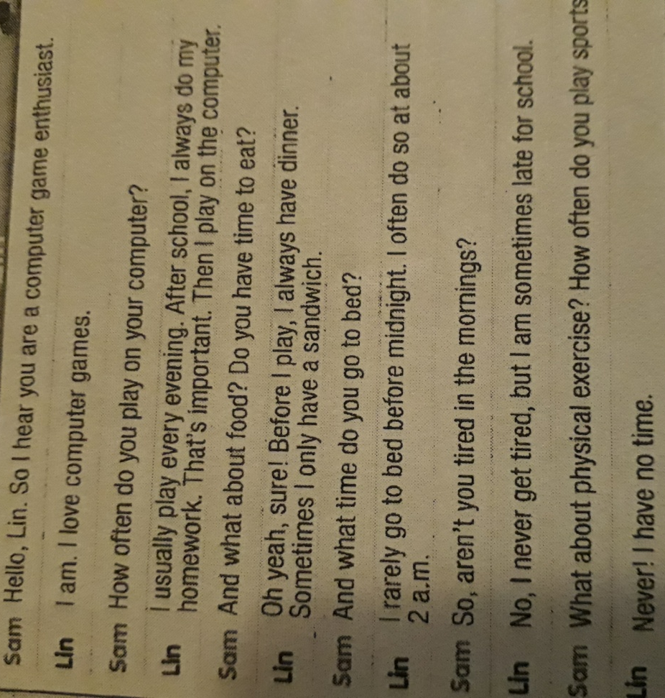
1. I usually play on his computer every evening / morning
2. He always / sometimes has a sandwich for dinner.
3. He often / rarely goes to bed after midnight.
4. He is often / sometimes late for school.
5. He never / rarely does physical exercise.

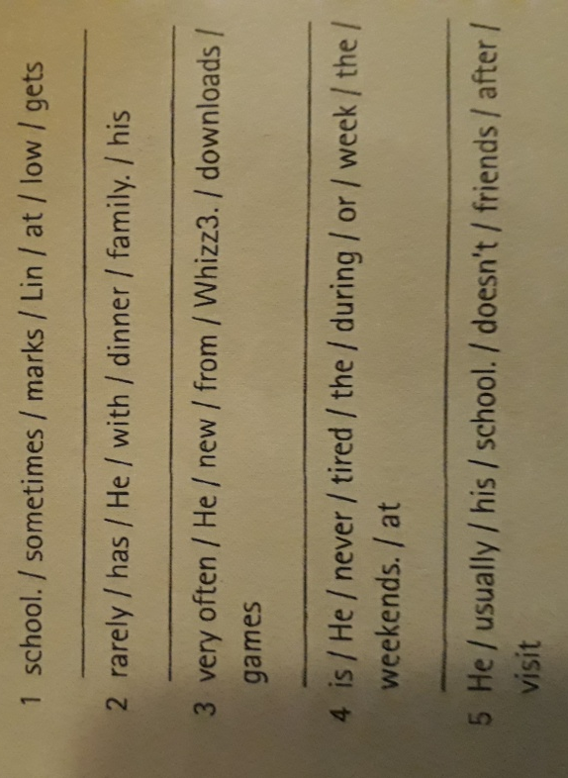
B) Unscramble these sentences

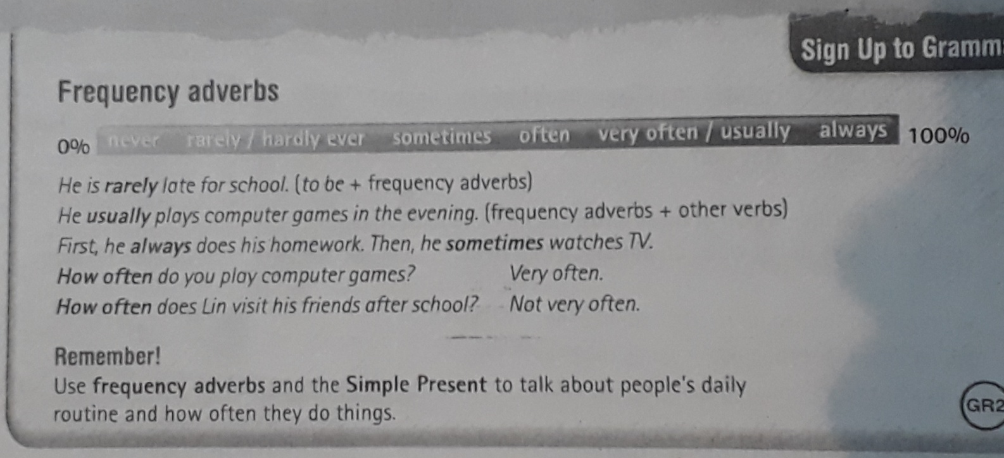
Grammar

