CPEM N° 46
CURSO: 4TO B
ÁREA: INGLÉS
Trabajo práctico N°6
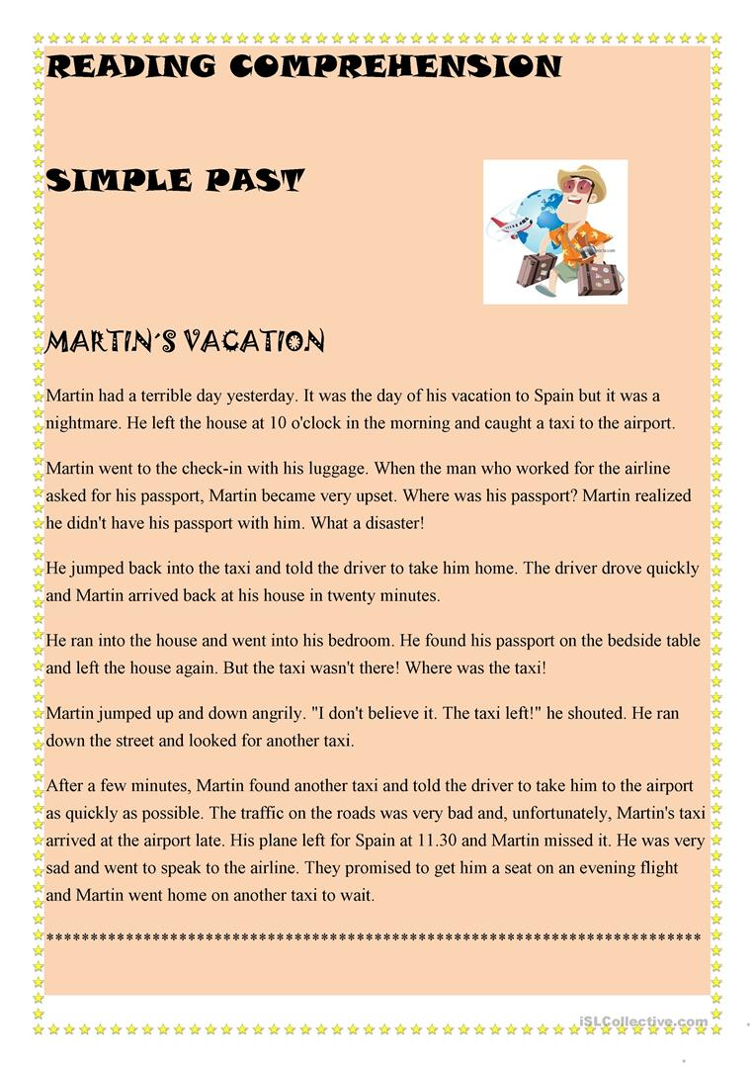
- Read the text:

- Look for the verbs in the PAST SIMPLE in the text:

REGULAR VERBS  (-ED) |  | IRREGULAR VERBS
WORK | WORKED | IS | WAS
SHOUT |  | HAVE
ARRIVE |  | GO
LOOK |  | LEAVE
JUMP |  | DRIVE
MISS |  | RUN
ASK |  | CATCH
PROMISE |  | FIND
REALIZE |  | BECOME
 |  | TELL

- CIRCLE TRUE OR FALSE
- Martin left the house at 8 o´clock TRUE / FALSE
- He went to the airport by taxi TRUE / FALSE
- He forgot his passport TRUE / FALSE
- His plane left for Spain at 12 o´clock TRUE / FALSE
- He was very happy TRUE / FALSE
- He went back home TRUE / FALSE

