Name: …………………………………….…….….. Date: ………………………………

4th year A, B,C and D

Importante: todas las actividades pueden realizarse con ayuda del libro que usamos en 3° año: 2014. Sign Up to English 2A Split Edition. Richmond
Serán corregidas al inicio de la cursada.

Part 1: Reading

Task 1: Read the magazine article and then circle the correct option in the sentences below. (10 marks)

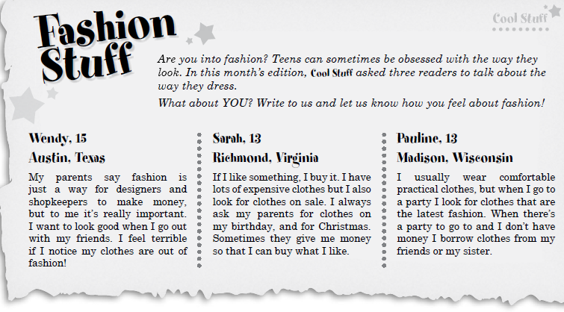

1. Wendy’s parents think / don’t think fashionable clothes are important.
2. Pauline likes / doesn’t like comfortable clothes.
3. Sarah always / sometimes buys clothes on sale.
4. Wendy doesn’t care / cares about fashion.
5. Sarah’s parents always / sometimes give her clothes as presents.

Task 2: Read the article again and write true (T), false (F) or not mentioned (NM). (10 marks)
1 [ ] Pauline always buys new clothes when she goes to a party.
2 [ ] Sarah doesn’t have many clothes.
3 [ ] Wendy buys new clothes every month.
4 [ ] Sarah loves buying sports clothes.
5 [ ] Pauline generally prefers to wear comfy practical clothes.

Part 2: Grammar, vocabulary and writing

Task 1: Unscramble these sentences. (20 marks)

1- parents / me / let / my / never / violent / watch / movies / .
2- sandwich / like / have / you / would / to / a / ?
3 - newspaper / teacher / read / makes / our / us / the / .
4 - food / eat / shouldn’t / junk / you / .
5 - clothes / buy / want / new / I / to / some / .
6 - I / casual / wear / should / the / clothes / party / to / ?
7 - hard / study / get / to / at / marks / they / good / school / .
8 - mother / makes / my / clean / me / bedroom / my / .
9 - to / new / I / pair / jeans / a / want / of / buy / .
10 - doesn’t / us / teacher / my / in / let / shout / class / .
Task 2: Spot the mistake in each sentence. Then rewrite the sentences correctly. (10 marks)

1. Do you like we? ____________________________________________.
2. Is that yours pen? ___________________________________________.
3. You can wear mine dress to go to the party. _________________________________.
4. Please ask she to phone me this evening. ___________________________________.
5. That iPhone isn’t mine, it’s her. ________________________________________.

Task 3: Write sentences about the issues mentioned below. (10 marks)

1. A film you want to see and why.
2. Something you shouldn’t do at school.
3. Something your parents make you do.
4. Something you think people in your country should do.
5. Something your teacher lets you do in the classroom
Task 4: Fill in the blanks using the words in the box. (10 marks)

cushions liberal strips wardrobe tie patient horoscope
messy dress microwave

1. My little sister loves reading comic _____________________.
2. Your bedroom is so __________________ ! How can you find your things in here?
3. I have many _____________________ on my bed as decoration.
4. It’s a formal dinner. You should wear a shirt and a _______________________.
5. My uncle wants to teach me how to drive. He’s very ______________________.
6. The chicken is frozen. Please put it in the ________________ to defrost.
7. She always reads the ___________________ page to know about her future.
8. My parents are very ___________________ and let me go out until late.
9. I should tidy my ____________________. It’s a mess and I can’t find my clothes!
10. I have a new ___________________ for tonight’s party.
Writing:
Task 5: Read the following post in a problem page section of an online magazine. Write your answer making suggestions and giving the writer some advice. (30 marks)

