CPEM N° 46
ÁREA: INGLÉS
Trabajo práctico N°3
IR AL SIGUIENTE LINK: https://youtu.be/i296bT8y2S4

I
You
He, she, it
we
you
they
PERSONAL PRONOUNS
(SUBJECT)

- Fill in the personal pronouns as in the example

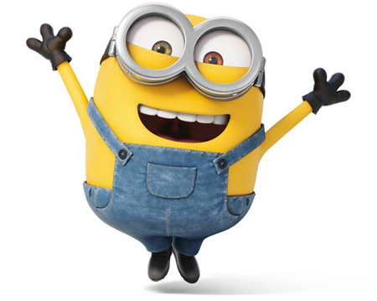
- Ann __she__ b) Peter ______
- mother ______ d) car ______
Good Work

- Nick and I ______ f) ball ______
- you and Carl ______ h) sister ______
- children ______ j) dogs______

- feet ______ l) house ______
- Tim and Mary ______ n) rubber ______

- Choose the right personal pronoun.
1. _______ is my friend. (I, he, they) 2. _______ is fat. (we, she, I)
3. _______ is a red skirt. (I, he, it) 4. _______ are very old. (he, they, I)
5. _______ are new pens. (we, I, they) 6. ________ am a queen. (he, I, we)
7. ________ are wild animals. (I, it, they) 8. _______ are men. (he, they, she)
8. ________ is an orange book. (I, he, it) 10.________ are red apples. (we, he, they)

3. Choose the right personal pronoun.

1. _______ is my friend. (I, he, they) 2. _______ is fat. (we, she, I)
3. _______ is a pink skirt. (I, he, it) 4. _______ are very old. (he, they, I)
5. _______ are new pens. (we, I, they) 6. ________ am a king. (he, I, we)
7. ________ are wild animals. (I, it, they) 8. _______ are men. (he, they, she)
8. ________ is an orange book. (I, he, it) 10.________ are red apples. (we, he, they)
11. ________ is at home. (I, we, she) 12. _______ is a pizza. (he, I, it)
13. ________ is a teacher. (it, you, she) 14._______ am very happy. (he, we, I)
Good Work

