Actividades de Inglés
Curso: 2ºB
Profesora: Somaruga, Gioia
Email para enviar el trabajo: gsomarug@hotmail.com
Fecha de Entrega: 26 de Octubre

Chicos/as: Recuerden detallar bien sus datos cuándo me envían el email con el Trabajo. Nombre y Apellido completo, Escuela, Curso y División. Gracias!
Hola Chicos y Chicas! Cómo están?! Espero que muy bien! Cerramos con el uso de los Adverbios de Frecuencia, en el uso del Presente Simple, en la Rutina. Este es el último Trabajo de Inglés del año.
We use some adverbs to describe how frequently we do an activity.
These are called adverbs of frequency and include:
Frequency | Adverb of Frequency | Example Sentence
100% | always | I always go to bed before 11 p.m.
90% | usually | I usually have cereal for breakfast.
80% | normally / generally | I normally go to the gym.
70% | often* / frequently | I often surf the internet.
50% | sometimes | I sometimes forget my wife's birthday.
30% | occasionally | I occasionally eat junk food.
10% | seldom | I seldom read the newspaper.
5% | hardly ever / rarely | I hardly ever drink alcohol.
0% | never | I never swim in the sea.

The Position of the Adverb in a Sentence
An adverb of frequency goes before a main verb (except with To Be).
Subject + adverb + main verb
I always remember to do my homework.
He normally gets good marks in exams.
- An adverb of frequency goes after the verb To Be.
Subject + to be + adverb
They are never pleased to see me.
She isn't usually bad tempered.
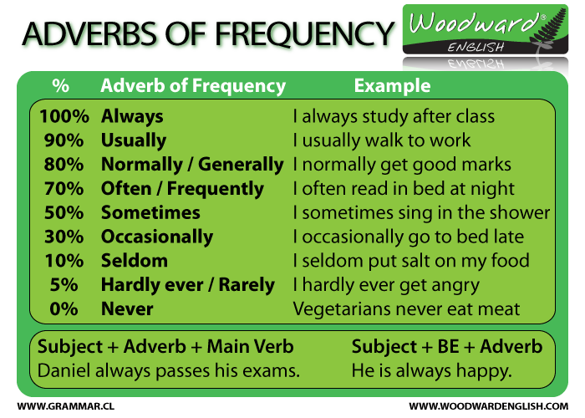

Actividades:
- Put the following adverbs of frequency in the correct order from the most often to the least often. Colocar los adverbios de mayor a menor frecuencia.
often
usually
always
never
seldom/rarely
sometimes
- Rewrite the complete sentence using the adverb of frequency in brackets in its correct position. Rehacer las oraciones colocando el adverbio de frecuencia en el lugar correcto.
- They go to the movies. (often)
- She listens to classical music. (rarely)
- He reads the local newspaper. (sometimes)
- Sara smiles. (never)
- She cooks lunch at home. (always)
- I drink coffee. (sometimes)
- Frank is ill. (often)
- He feels terrible (usually)
- I go jogging in the morning. (always)
- She helps her daughter with her homework. (never)
- We watch television in the evening. (always)
- I smoke. (never)
- I eat meat. (seldom)
- I eat vegetables and fruits. (always)

