Inglés cuarto Año
Please, do the activities on the following pages. You can use an English-Spanish dictionary. If you don’t have a dictionary at home, you can use these on line.
https://www.collinsdictionary.com/es/traductor This one is very similar to Google translator, so I guess you’ll like it. Please, don’t use Google translator. It has many mistakes.
https://www.linguee.es/
https://dictionary.cambridge.org/es/diccionario/ingles-espanol/
https://www.wordreference.com/es/en/translation.as

You must hand in on Monday 6th April. Send your answers to this address: ceciliacalantoni@gmail.com

Name: …………………………………….…….….. Date: ………………………………

4th year A, B,C and D

Part 1: Reading
A) Read the magazine article and then circle the correct option in the sentences below. (10 marks)

Fashion Stuff
Are you into fashion? Teens can sometimes be obsessed with the way they look. In this month’s edition, Cool Stuff asked three readers to talk about the way they dress.
What about YOU? Write to us and let us know how you feel about fashion!

Juliette, 15
Phoenix, Arizona

I don’t really care about clothes.
I just like my clothes to be
practical and comfortable. My mom sometimes buys me clothes that she thinks will make me “look like a girl”, but I just give them to my friends.

Johanna, 14
New York, NY

I don’t care about clothes very much, but I must confess I am really obsessed with shoes. I
think I have more than 50 pairs! Some were really expensive, others are not very comfortable and I have five or six pairs that
are completely out of fashion, but I don’t care. I think they’re all beautiful!

Susie, 14
Columbus, Ohio

I like wearing clothes that are the latest fashion and I can spend more than $200 on a dress or a pair of sunglasses, but I’m not really obsessed with that. When I don’t have money I just look for things on sale.

1 Juliette’s mother likes / doesn’t like her daughter’s clothes.
2 Fashion isn’t important for Juliette / Susie.
3 Susie always / sometimes buys expensive clothes.
4 Juliette keeps / doesn’t keep the clothes her mother buys her.
5 Some / All of Johanna’s shoes are fashionable.

B) Read the article again and write true (T), false (F) or not mentioned (NM). (10 marks)

1 [ ] Johanna always buys comfortable shoes.
2 [ ] Susie loves buying jeans.
3 [ ] Juliette doesn’t like uncomfortable clothes.
4 [ ] Juliette prefers clothes that are neutral in colour.
5 [ ] Johanna likes all her shoes.

Part 2: Grammar, vocabulary and writing

C) Unscramble these sentences. (20 marks)

1 me / parents / study / day / make / every / my / ………………………………………………………………
2 mother / should / you / help / your / ……………………………………………………………………………
3 lunch / wants / Patrick / sleep / after / to / always / …………………………………………………………..
4 I / style / should / my / change / clothing / ? …………………………………………………………………..
5 you / lots / wear / make-up / shouldn’t / of / …………………………………………………………………...
6 run / I / keep / usually / to / fit / ………………………………………………………………………………….
7 to / don’t / clothes / I / wear / want / formal / ………………………………………………………………….
8 eat / your / class / teacher / does / let / in / you / ? …………………………………………………………...
9 my / me / doesn’t / father / let / drive / …………………………………………………………………………
10 for / this / she / a / needs / summer / swimsuit / new / ………………………………………………………

D) Spot the mistake in each sentence. Then rewrite the sentences correctly. (10 marks)

1 Excuse me, is this wallet your? ………………………………………………………………………………...
2 Whose keys are these? I don’t know. They aren’t my. ………………………………………………………
3 I don’t like she very much. ………………………………………………………………………………………
4 Their team is good but our is excellent! ……………………………………………………………………….
5 Can you tell they to come over here, please? ………………………………………………………………..

E) Circle the correct option. (5 marks)

1 There is ice cream in the freezer.
many not many quite a lot of

2 Johnny doesn’t drink milk.
many much lots

3 I need eggs to make a cake.
much any some

4 I usually eat vegetables and fruit in summer.
a little lots of much

5 She generally has coffee with sugar and milk.
a little few many

F) Fill in the blanks with a suitable object pronoun:
me, him, her, it, us or them.

1 Sophia: What do you think of Jennifer Lopez?
Olivia: I like …………… a lot. I think she’s a good singer and actress.
2 Helen is married to Paul but she doesn’t live with ……………… any more.
3 Dad: Do you play football with those boys?
Max: No, I never play football with ………………. We play cricket together!
4 You can have this T-shirt. I never wear ………………..
5 My parents don’t let ………………….. go out after midnight.
6 My sister and I think our mum is very creative. She usually designs clothes for the two of …………………. !

Reading comprehension
1) Read the text and answer the questions (long answers).
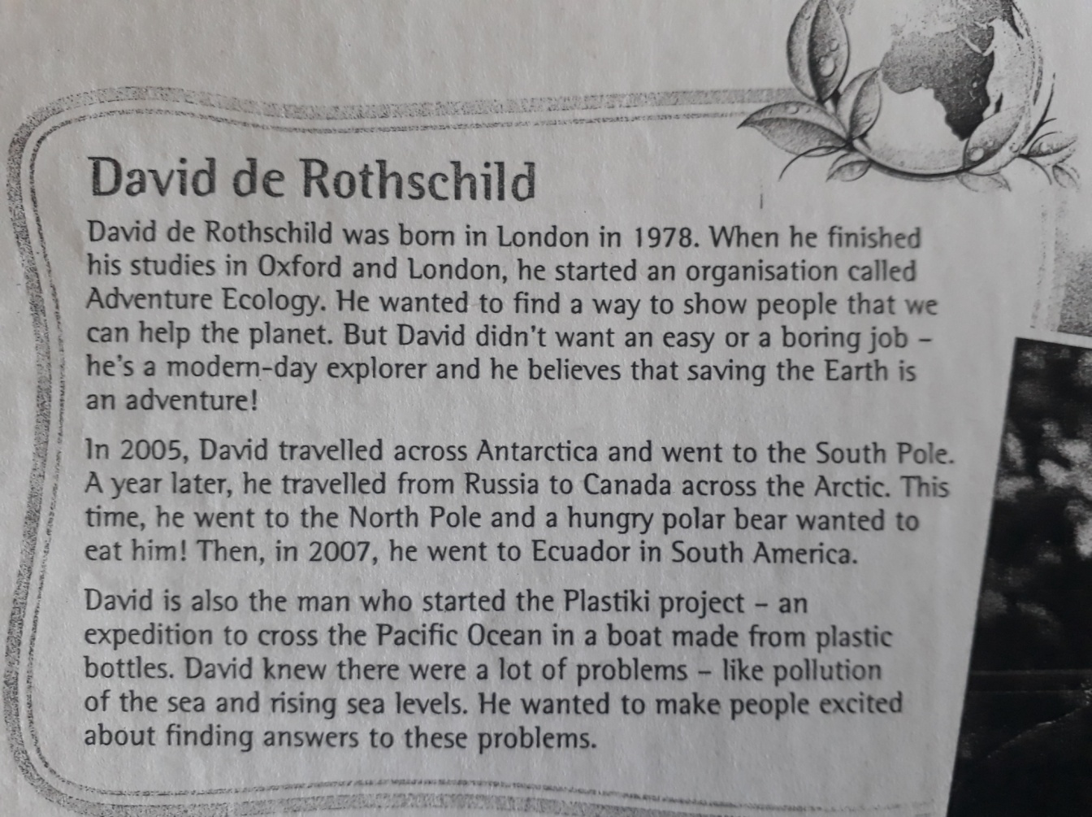
True story

- When was he born? ………………………………………………………………………………………………………………….
- Where was he a student? …………………………………………………………………………………………………………
- What is the name of the organization that he started? ……………………………………………………………
………………………………………………………………………………………………………………………………………………….
- Is his job boring or interesting? ………………………………………………………………………………………………..
- Where was he in 2005? …………………………………………………………………………………………………………….
- What happened to him at the North Pole? ……………………………………………………………………………….
………………………………………………………………………………………………………………………………………………….
- What was the Plastiki project? …………………………………………………………………………………………………
…………………………………………………………………………………………………………………………………………………
B) Find the English version for:
1. Salvar el planeta tierra: ……………………………………………………………………………………………………….
2. hambriento: ……………………………………………………………………………………………………………………….
3. crecimiento de los niveles del mar: ……………………………………………………………………………………
4. entusiasmados: ………………………………………………………………………………………………………………….

C) What are the irregular verbs that appear in the text?

.....................................................................................................................................................................

